📘 Special Issue: Honoring Dr. Akwo Thompson Ntuba
WWW.HEALTHNDEVELOPMENT.COM

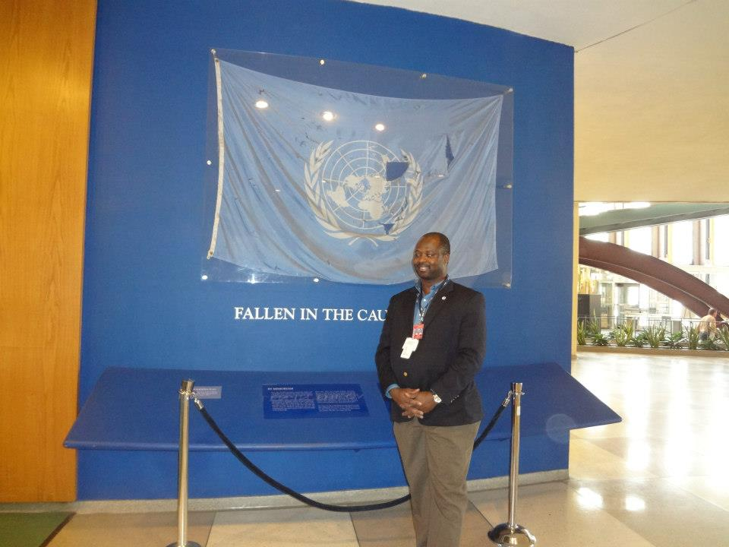
DR AKWO THOMPSON WORKS AT THE UNITED NATIONS NEW YORK USA
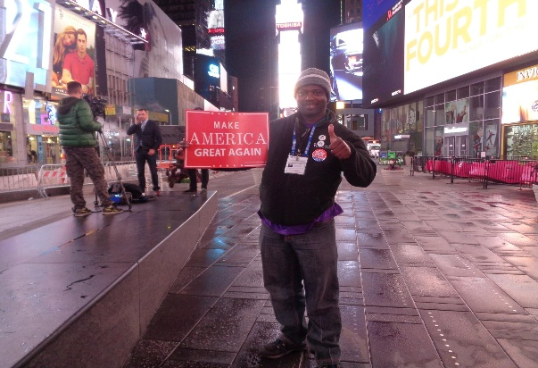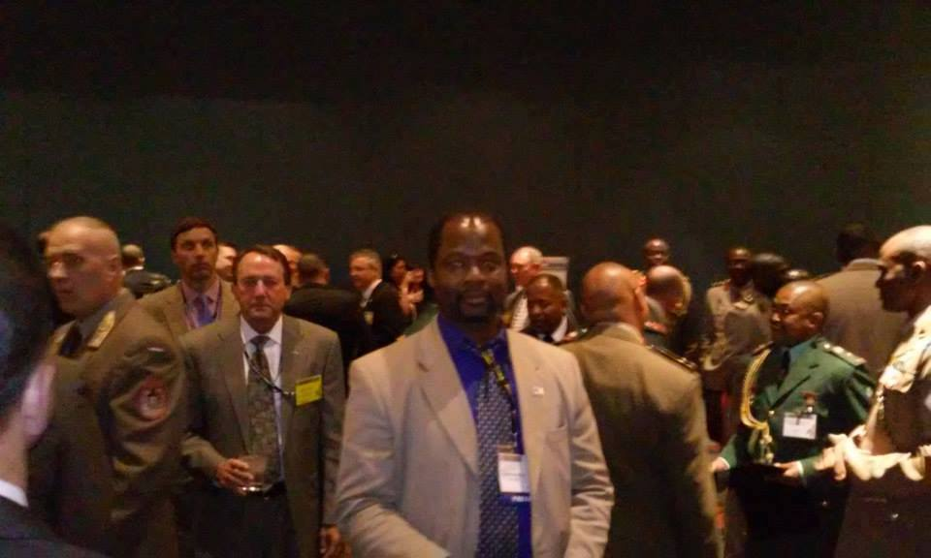
DR AKWO THOMPSON , NEW YORK DR AKWO THOMPSON , AUSA DC USA

PAGE 1 — FRONT COVER
HEALTH & DEVELOPMENT MAGAZINE Global Health • Leadership • Governance • Human Development
COVER TITLE: DR. AKWO THOMPSON NTUBA Three Decades of Global Health, Leadership & Humanitarian Impact.
A physician, communicator, and global development advocate whose work spans continents, strengthens health systems, and uplifts communities.

FEATURE TEASERS:
- Global Health Communication Excellence
- Strengthening Health Systems Worldwide
- Ministry Without Borders
- Civic Journalism in Public-Health Emergencies
- Exclusive Interview: “My Life’s Work Is Service.”
COVER CAPTION: Dr. Akwo Thompson Ntuba at the United Nations Headquarters — honoring those who gave their lives in the cause of peace.
PAGE 2 — EDITOR’S NOTE
From the Editor
In a world shaped by rapid change, persistent inequities, and evolving public-health challenges, leadership rooted in service has never been more essential. This special issue of Health & Development Magazine honors a man whose life’s work embodies that principle: Dr. Akwo Thompson Ntuba.
For nearly three decades, Dr. Ntuba has stood at the intersection of medicine, communication, governance, and ministry. His journey spans continents and disciplines — from health-system strengthening and civic journalism to global ministry and humanitarian outreach. His work reminds us that health is not merely the absence of disease; it is the presence of dignity, justice, and opportunity.
This issue celebrates his contributions, explores the systems he has helped shape, and reflects on the values that guide his service. May his story inspire leaders, practitioners, and communities around the world.
— Editor-in-Chief, Health & Development Magazine

PAGE 3 — TABLE OF CONTENTS
- Cover Story: A Life of Service
- Global Health Communication Excellence
- Strengthening Health Systems Worldwide
- Ministry Without Borders
- Civic Journalism & Public-Health Leadership
- Special Report: Health Equity in the 21st Century
- Voices From the Field
- Photo Essay: A Journey Across Continents
- Exclusive Interview: “My Life’s Work Is Service”
- Closing Reflections

PAGE 4–5 — COVER STORY SPREAD
A LIFE OF SERVICE
The Global Impact of Dr. Akwo Thompson Ntuba
For more than 30 years, Dr. Akwo Thompson Ntuba has dedicated his life to advancing global health, strengthening communities, and uplifting humanity. His work spans medicine, public health, governance, journalism, and ministry — a rare combination that has allowed him to serve people in holistic and transformative ways.
Born with a deep sense of purpose, Dr. Ntuba’s early years were shaped by a passion for healing and a commitment to justice. His medical training laid the foundation for a career that would soon expand far beyond the clinic. He recognized early that health outcomes are shaped not only by biology but by communication, leadership, and the systems that govern society.
A Global Footprint
From the United States to Africa and beyond, Dr. Ntuba has worked with governments, faith communities, media institutions, and health organizations to improve lives. His presence at international institutions — including the United Nations — reflects his commitment to global peace, development, and human dignity.
A Legacy of Leadership
Whether advising health systems, reporting on public-health emergencies, or ministering to communities in need, Dr. Ntuba’s leadership is grounded in compassion and guided by faith. His work demonstrates that service is not a profession — it is a calling.
PAGE 6 — GLOBAL HEALTH COMMUNICATION EXCELLENCE
Bridging Science and Society
Effective communication saves lives. Throughout his career, Dr. Ntuba has been a trusted voice in public health, translating complex medical information into accessible, actionable knowledge.
As Editor-in-Chief of Health & Development Magazine, he has shaped global conversations on health equity, infectious diseases, development policy, and community resilience. His reporting during public-health crises — including the COVID-19 pandemic — provided clarity at a time of confusion.
He has covered major scientific and medical conferences, bringing insights from leading experts to communities that need them most. His work ensures that knowledge does not remain locked in institutions but reaches the people it is meant to serve.
PAGE 7 — STRENGTHENING HEALTH SYSTEMS WORLDWIDE
Leadership That Transforms Institutions
As President and CEO of Health Consulting International, Dr. Ntuba has spent decades helping organizations strengthen governance, improve care delivery, and build sustainable health systems.
His work includes:
- Leadership development for health executives
- Governance training for boards and institutions
- Integrative and recovery-care consulting
- Support for community-based health programs
- Cross-continental collaboration between U.S. and African institutions
His approach is rooted in the belief that strong systems create strong communities — and that leadership is the engine of sustainable change.
PAGE 8 — MINISTRY WITHOUT BORDERS
Faith in Action
For nearly 25 years, Dr. Ntuba has served as a global Christian minister, bringing healing, hope, and spiritual renewal to communities around the world.
His ministry includes:
- Evangelistic outreach
- Healing services
- Leadership development for pastors
- Youth and women’s empowerment
- Grief and trauma support
As a member of the International Charismatic Bible Ministries (ICBM), he continues to build bridges between faith and public service. His ministry reflects a holistic understanding of health — one that embraces body, mind, and spirit.
PAGE 9 — CIVIC JOURNALISM & PUBLIC-HEALTH LEADERSHIP
A Voice for Communities
Dr. Ntuba’s work in civic journalism has positioned him as a vital link between governments and the public. As a media partner to U.S. city governments — including the City of Houston — he has covered public-health initiatives, emergency responses, and development programs.
During crises, his reporting has helped communities understand evolving guidance, access resources, and stay informed. His journalism is rooted in service, integrity, and a commitment to truth.
PAGE 10 — SPECIAL REPORT
Health Equity in the 21st Century
Health equity remains one of the most urgent challenges of our time. In this special report, we examine:
- Structural barriers to health
- Global disparities in access and outcomes
- The role of governance in shaping health systems
- Community-driven solutions
- Dr. Ntuba’s advocacy for equitable care
The path to equity requires courage, collaboration, and leadership — qualities Dr. Ntuba has demonstrated throughout his career.
PAGE 11 — EXCLUSIVE INTERVIEW
“My Life’s Work Is Service”
A Conversation with Dr. Akwo Thompson Ntuba
Q1. What inspired your journey into global health and development? Service has always been at the center of my life. I saw early that healing extends beyond medicine — it touches every part of society.
Q2. How do you balance your roles in medicine, communication, and ministry? They are not separate. They are different expressions of the same calling: to serve people.
Q3. What has been your most meaningful moment of service? Moments when communities find hope again — that is where I see purpose fulfilled.
Q4. What challenges remain in global health? Equity, governance, and communication. We must strengthen systems and empower communities.
Q5. What advice do you have for emerging leaders? Lead with humility. Serve with integrity. And never lose sight of the people behind the policies.
PAGE 12 — BACK COVER
Closing Reflections
Service is the thread that weaves through every chapter of Dr. Akwo Thompson Ntuba’s life. His work reminds us that leadership is not measured by titles but by impact — by the lives touched, the systems strengthened, and the hope restored.
As we close this special issue, we honor his legacy and look forward to the next decade of his global influence.
Health & Development Magazine www.healthndevelopment.com Issue 01 • 2026

COVER STORY
A LIFE OF SERVICE
The Global Impact of Dr. Akwo Thompson Ntuba
For nearly three decades, Dr. Akwo Thompson Ntuba has walked a path shaped by purpose, sharpened by discipline, and sustained by an unwavering commitment to humanity. His journey — spanning medicine, governance, communication, ministry, and global development — is not the story of a career. It is the story of a calling.
From the red earth of his childhood to the marble halls of international institutions, Dr. Ntuba has carried one conviction with him: service is the highest form of leadership. Every chapter of his life reflects that truth.
A Childhood Shaped by Responsibility
Long before he became a physician, communicator, and global advocate, Dr. Ntuba learned the meaning of responsibility in the most intimate way — through family, community, and faith. Those early lessons formed the foundation of a worldview that sees leadership not as authority, but as stewardship.
He grew up watching how communities survive through cooperation, how elders protect the vulnerable, and how faith anchors people through hardship. These experiences would later become the moral compass guiding his work across continents.
Medicine as a Mission
When Dr. Ntuba entered medicine, he did so with a sense of reverence. Healing, to him, was never merely clinical — it was spiritual, social, and deeply human. His medical training opened the door to a broader understanding of health: that people do not suffer in isolation, and that illness is often a symptom of deeper systemic failures.
This insight propelled him beyond the walls of the clinic and into the world of public health, governance, and communication, where he could influence the structures that shape people’s lives.
A Communicator for the Global Public
As Editor-in-Chief of Health & Development Magazine, Dr. Ntuba became a bridge between science and society. He translated complex medical knowledge into language that communities could understand and act upon. His reporting during public-health emergencies — including the COVID-19 pandemic — provided clarity at a time when misinformation threatened lives.
He covered major scientific conferences, interviewed leading experts, and ensured that the insights of global health leaders reached the people who needed them most. His work democratized knowledge and strengthened public trust.
Leadership Across Continents
Through Health Consulting International, Dr. Ntuba has advised institutions across the United States, Africa, and Europe. His work in governance, recovery care, and health-system strengthening reflects a deep understanding of how leadership shapes outcomes.
He has trained executives, supported boards, and helped organizations build systems that are resilient, ethical, and community-centered. His leadership philosophy is simple yet profound: “Strong systems protect people. Weak systems fail them.”
Ministry Without Borders
Parallel to his medical and governance work runs another thread: ministry. For more than 25 years, Dr. Ntuba has served as a global Christian minister, offering healing, hope, and spiritual guidance to communities around the world.
His ministry has taken him into hospitals, prisons, refugee communities, and churches across continents. He has preached, counseled, comforted, and empowered — always with humility and compassion.
To him, faith is not separate from public service. It is the wellspring that sustains it.
A Witness to History
The image of Dr. Ntuba standing at the United Nations memorial wall — honoring those who died in the cause of peace — captures the essence of his journey. He has been present in moments of global significance, not as a spectator, but as a servant-leader committed to justice, dignity, and human development.
His work has taken him into the heart of governance crises, public-health emergencies, and community struggles. He has documented, advised, advocated, and ministered — always with the same quiet conviction.
A Legacy Still Unfolding
Three decades into his journey, Dr. Ntuba’s impact continues to expand. His work in global health communication, governance, ministry, and civic journalism has touched thousands of lives and strengthened countless institutions.
But ask him what he is most proud of, and he will not speak of titles, conferences, or accolades. He will speak of people — the communities he has served, the leaders he has mentored, the patients he has comforted, the families he has supported, and the young people he has inspired.
His legacy is not measured in achievements. It is measured in lives uplifted.
The Call That Continues
As the world faces new challenges — pandemics, inequities, governance failures, and social fragmentation — leaders like Dr. Ntuba remind us that service is still the most powerful force for change.
His life stands as a testament to what is possible when one person commits to healing not just bodies, but systems… not just communities, but nations… not just individuals, but generations.
This is the story of a life lived in service. And the story is still being written.

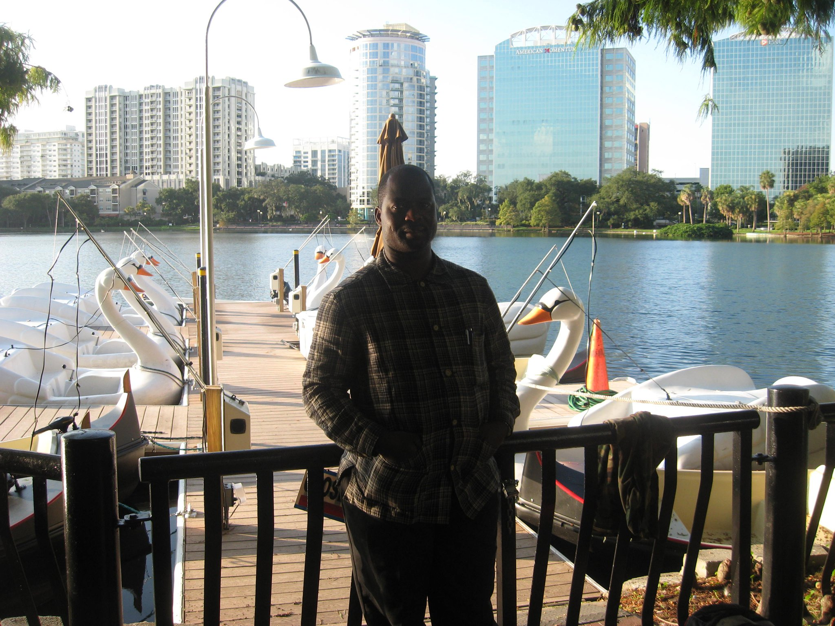
2. GLOBAL HEALTH COMMUNICATION EXCELLENCE
Bridging Science, Society, and the Human Story
For more than three decades, Dr. Akwo Thompson Ntuba has stood at the crossroads of medicine, media, and public service — shaping how communities understand health, how institutions communicate risk, and how societies respond to crisis. His work in global health communication is not simply informational; it is transformational.
At a time when misinformation spreads faster than disease, and when public trust is as fragile as public health itself, Dr. Ntuba has emerged as a steady, credible, and compassionate voice. His communication philosophy is grounded in a simple truth: people cannot act on information they do not understand.
A Voice That Makes Science Human
Dr. Ntuba’s communication style is distinct — authoritative yet accessible, scientific yet deeply human. He has the rare ability to translate complex medical concepts into language that resonates with everyday people, policymakers, and global audiences alike.
Whether reporting from a major medical conference, interviewing global health leaders, or writing for Health & Development Magazine, he brings clarity to complexity. His work ensures that the insights of researchers, clinicians, and public-health experts do not remain trapped in academic journals but reach the communities they are meant to serve.
His communication is not merely about facts; it is about context, compassion, and connection.
Leadership During Public-Health Emergencies
During the COVID-19 pandemic — one of the most disruptive global crises of the century — Dr. Ntuba’s voice became a lifeline for many. As misinformation surged and communities struggled to make sense of evolving guidance, he provided:
- Clear, evidence-based explanations
- Updates from scientific and governmental institutions
- Interviews with frontline experts
- Community-centered messaging tailored to vulnerable populations
His reporting helped bridge the gap between public-health authorities and the people most affected by the crisis. In moments of fear and uncertainty, he offered steadiness and truth.
Amplifying Global Health Voices
Through his editorial leadership at Health & Development Magazine, Dr. Ntuba has created a platform where global health professionals, policymakers, and community leaders can share insights, innovations, and lived experiences.
He has covered and documented:
- NIH-related scientific briefings
- American College of Allergy, Asthma & Immunology (ACAAI) conferences
- Global health diplomacy events
- Governance and development summits
- Community-based health initiatives across continents
His work democratizes knowledge — ensuring that global health is not an elite conversation but a shared responsibility.
Communication as Governance
Dr. Ntuba understands that communication is not an accessory to governance; it is a pillar of it. Effective health governance depends on:
- Transparency
- Trust
- Timely information
- Cultural competence
- Community engagement
His communication work strengthens these pillars. By helping institutions communicate clearly and ethically, he supports stronger health systems and more resilient communities.
A Mentor to the Next Generation
Beyond his public work, Dr. Ntuba has invested deeply in mentoring emerging communicators, health leaders, and community advocates. He teaches them that communication is not about speaking loudly — it is about speaking responsibly.
He emphasizes:
- Accuracy over speed
- Empathy over ego
- Service over spectacle
His mentorship ensures that the next generation of global health communicators will be grounded in integrity and guided by purpose.
A Legacy of Clarity, Courage, and Compassion
In an era defined by noise, Dr. Akwo Thompson Ntuba has chosen to be a signal — clear, steady, and grounded in truth. His contributions to global health communication have saved lives, strengthened institutions, and empowered communities across continents.
His work reminds us that communication is not just about information. It is about dignity, justice, and the right of every person to understand the forces that shape their health.
This is the excellence he brings to the world. This is the legacy he continues to build.

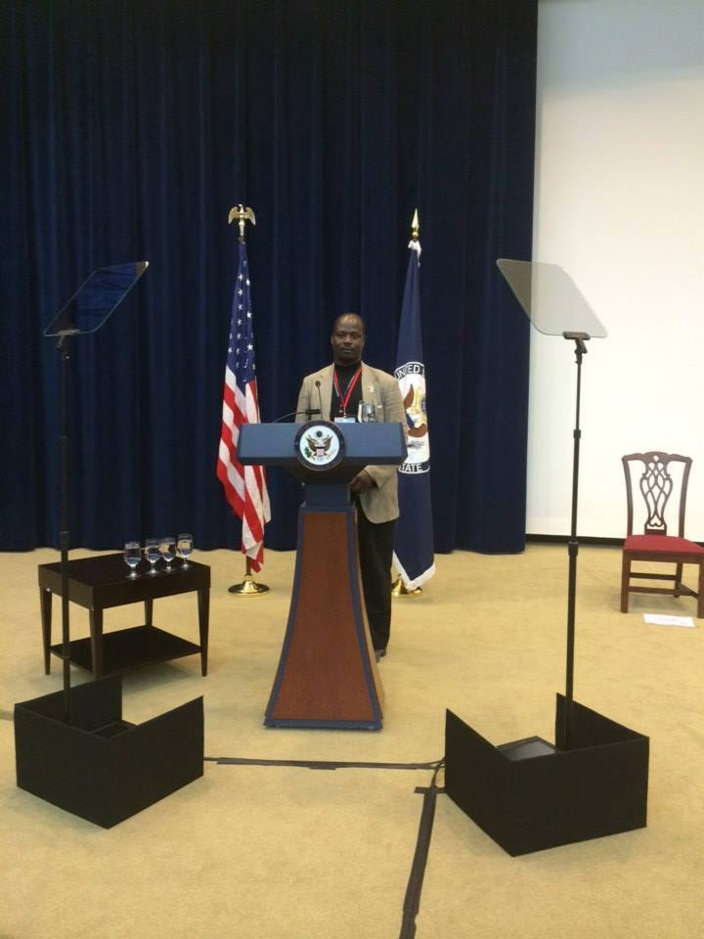
3. STRENGTHENING HEALTH SYSTEMS WORLDWIDE
Leadership That Builds Institutions, Protects Communities, and Shapes the Future
Across continents and across decades, Dr. Akwo Thompson Ntuba has worked at the heart of one of humanity’s most urgent challenges: building health systems that are strong, equitable, and resilient. His work in health-system strengthening is not theoretical — it is lived, practiced, and grounded in real communities, real institutions, and real human needs.
From boardrooms in the United States to ministries of health in Africa, from recovery-care programs to governance reform initiatives, Dr. Ntuba has helped organizations confront the structural weaknesses that undermine health — and replace them with systems that serve, protect, and empower.
A Vision Rooted in Systems Thinking
Dr. Ntuba approaches health not as a single sector, but as an ecosystem. He understands that hospitals, clinics, ministries, communities, and governments are interconnected — and that failure in one part of the system can ripple across an entire nation.
His philosophy is clear: “Strong systems protect people. Weak systems fail them.”
This belief has guided his work for more than 30 years, shaping his contributions to governance, leadership development, and institutional reform.
Governance as the Foundation of Health
At the core of Dr. Ntuba’s work is governance — the often invisible architecture that determines whether health systems thrive or collapse. Through Health Consulting International, he has helped institutions:
- Strengthen board leadership
- Improve accountability and transparency
- Build ethical decision-making frameworks
- Develop long-term strategic plans
- Align organizational culture with community needs
His governance work is not about bureaucracy; it is about building trust, the currency of every successful health system.
Leadership Development for a Changing World
Health systems rise or fall on the quality of their leaders. Recognizing this, Dr. Ntuba has spent decades training executives, clinicians, administrators, and community leaders to navigate complexity with clarity and compassion.
His leadership programs emphasize:
- Ethical decision-making
- Crisis management
- Communication during emergencies
- Community-centered planning
- Cross-sector collaboration
He teaches leaders that technical expertise is not enough — they must also understand people, culture, and the social forces that shape health.
Integrative and Recovery-Care Innovation
One of Dr. Ntuba’s most impactful contributions has been in the field of integrative and recovery care, where he has helped organizations design programs that address the full spectrum of human need.
His work has supported:
- Addiction recovery centers
- Mental-health and behavioral-health programs
- Holistic care models
- Community-based rehabilitation initiatives
He champions approaches that treat individuals not as cases, but as whole human beings — with physical, emotional, social, and spiritual dimensions.
Cross-Continental Collaboration
Dr. Ntuba’s work bridges continents, connecting institutions in the United States, Africa, and Europe. He has facilitated partnerships that:
- Strengthen primary-care systems
- Improve emergency preparedness
- Expand access to essential medicines
- Support health-worker training
- Enhance data systems and monitoring
These collaborations reflect his belief that global health is a shared responsibility — and that knowledge must flow across borders.
A Practitioner of Practical Solutions
What sets Dr. Ntuba apart is his commitment to practical, community-centered solutions. He does not impose models from above; he listens, observes, and builds systems that reflect the realities of the people they serve.
His work is grounded in:
- Cultural competence
- Respect for local leadership
- Evidence-based practice
- Long-term sustainability
- Community empowerment
This approach has earned him the trust of institutions and communities alike.
A Legacy of Strengthened Systems
The impact of Dr. Ntuba’s work can be seen in:
- More resilient health institutions
- Better-trained leaders
- Stronger governance structures
- Improved community health outcomes
- Greater collaboration across sectors and continents
His contributions have helped shape systems that will continue to protect and uplift people for generations.
Building the Future of Global Health
As the world faces new threats — pandemics, climate-driven health crises, migration pressures, and widening inequities — the need for strong health systems has never been greater.
Dr. Ntuba’s work offers a blueprint for the future: systems that are ethical, resilient, community-centered, and grounded in service.
His leadership reminds us that strengthening health systems is not just a technical task — it is a moral one.

4. MINISTRY WITHOUT BORDERS

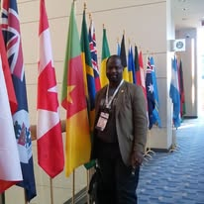
Faith in Action, Healing Across Nations, and a Calling That Transcends Geography
Long before titles, conferences, and global platforms, Dr. Akwo Thompson Ntuba understood that service begins with the heart. His ministry — spanning more than 25 years and crossing continents, cultures, and generations — is rooted in a simple but profound conviction: healing is holistic. It touches the body, the mind, the spirit, and the community.
To Dr. Ntuba, ministry is not a profession. It is a calling. And that calling has carried him into villages, cities, hospitals, churches, prisons, refugee communities, and international gatherings — wherever people are in need of hope, dignity, and restoration.
A Ministry Shaped by Compassion
Dr. Ntuba’s ministry began quietly, through acts of compassion that reflected the values instilled in him from childhood: care for the vulnerable, respect for elders, and a deep belief in the transformative power of faith.
Over the years, that ministry expanded into a global mission. He has preached, taught, counseled, and comforted people across Africa, Europe, and the United States. His message is consistent: God’s love is practical, healing, and liberating.
His ministry is not defined by buildings or borders — it is defined by presence.
Healing That Honors the Whole Person
In every community he serves, Dr. Ntuba brings a holistic approach to healing. He understands that spiritual wounds often manifest as physical suffering, and that emotional pain can weaken the body. His ministry integrates:
- Prayer and spiritual healing
- Counseling for grief, trauma, and loss
- Support for families and caregivers
- Encouragement for youth and emerging leaders
- Empowerment for women and marginalized groups
He ministers not only to individuals but to the systems that shape their lives — advocating for justice, equity, and compassion in governance and public health.
A Shepherd to Leaders
One of the most distinctive aspects of Dr. Ntuba’s ministry is his work with leaders. As a mentor to pastors, ministers, and community organizers, he helps them navigate the complexities of modern ministry with wisdom, humility, and integrity.
He teaches that leadership is not about prominence but about service — that the true measure of a leader is the wellbeing of their people. His mentorship has strengthened ministries across continents, equipping leaders to serve with courage and clarity.
A Global Christian Voice
As a member of the International Charismatic Bible Ministries (ICBM) — a global network founded by Oral Roberts — Dr. Ntuba stands among leaders committed to advancing faith, healing, and spiritual renewal worldwide.
Through this platform, he has participated in global dialogues on ministry, humanitarian service, and the role of faith in public life. His contributions reflect a deep understanding of how spiritual leadership intersects with health, governance, and community development.
Ministry in Moments of Crisis
Dr. Ntuba’s ministry has often placed him at the frontlines of human suffering. He has prayed with families in hospitals, comforted communities after tragedy, and supported individuals navigating addiction, displacement, and loss.
During public-health emergencies, he has served as both a spiritual and informational anchor — offering guidance that blends faith with evidence-based health communication. His presence brings calm where fear threatens to overwhelm.
Faith That Walks With People
What sets Dr. Ntuba’s ministry apart is its mobility. He does not wait for people to come to him — he goes to them. His ministry has taken him:
- Into rural villages with limited access to healthcare
- Into urban communities facing poverty and violence
- Into churches seeking revival and renewal
- Into civic spaces where faith and governance intersect
- Into international forums where spiritual and humanitarian issues converge
His ministry is a journey, not a destination.
A Legacy of Hope
Across continents, people speak of Dr. Ntuba not only as a minister, but as a healer, counselor, advocate, and friend. His ministry has restored families, strengthened communities, and inspired countless individuals to pursue lives of purpose and service.
His message is timeless: Faith is not passive. Faith acts. Faith heals. Faith builds. Faith serves.
A Calling That Continues
As the world faces new challenges — from social fragmentation to mental-health crises, from displacement to spiritual exhaustion — Dr. Ntuba’s ministry remains a beacon of hope.
He continues to serve with humility, courage, and compassion, reminding us that borders may divide nations, but they cannot divide the human spirit.
His ministry is not confined to geography. It is carried in every life he touches.
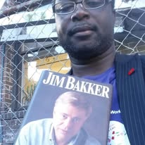
6 Civic Journalism & Public-Health Leadership
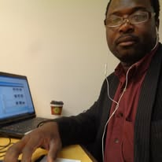
5. CIVIC JOURNALISM & PUBLIC-HEALTH LEADERSHIP
A Voice for Communities, A Bridge Between Institutions and the People They Serve
In every society, there are moments when information becomes as essential as medicine — moments when clarity can save lives, and silence can cost them. For more than three decades, Dr. Akwo Thompson Ntuba has stepped into those moments with purpose, precision, and compassion. His work in civic journalism and public-health leadership has made him one of the most trusted communicators in times of crisis and transformation.
Dr. Ntuba’s journalism is not about headlines. It is about service — ensuring that communities receive the truth they need to protect themselves, advocate for their rights, and participate in the decisions that shape their lives.
Journalism as a Public-Health Tool
Dr. Ntuba’s approach to journalism is rooted in the belief that information is a form of care. When communities understand the risks they face, the resources available to them, and the policies that govern their wellbeing, they are empowered to act.
Through his reporting, he has:
- Explained complex public-health guidance in accessible language
- Covered emergency responses and crisis-management efforts
- Documented community needs during disasters
- Amplified the voices of frontline workers
- Held institutions accountable with fairness and integrity
His journalism strengthens the social fabric that public health depends on.
A Trusted Media Partner to Civic Institutions
In the United States, Dr. Ntuba has served as a media partner to city governments — including the City of Houston — during some of the most challenging public-health moments of the past decade.
He has covered:
- Public-health briefings
- Emergency preparedness initiatives
- Community-health campaigns
- Governance transitions
- Civic events that shape local and national policy
His reporting has helped bridge the gap between government institutions and the communities they serve, ensuring that public-health messaging is not only heard but understood.
Leadership During Public-Health Emergencies
During crises such as the COVID-19 pandemic, Dr. Ntuba’s work became a stabilizing force. As misinformation spread rapidly and communities struggled to navigate uncertainty, he provided:
- Accurate, evidence-based updates
- Interviews with medical and scientific experts
- Contextual analysis of evolving policies
- Community-specific guidance for vulnerable populations
- Clear explanations of risk, prevention, and response
His communication helped reduce fear, counter misinformation, and support community resilience.
Documenting Governance in Real Time
Beyond public health, Dr. Ntuba has chronicled governance challenges, leadership transitions, and civic decision-making processes. His work captures the human side of governance — the leaders, the communities, the tensions, and the triumphs.
He has documented:
- City-level governance reforms
- Public-health leadership failures and successes
- Community-driven advocacy movements
- The intersection of health, justice, and policy
His reporting provides a historical record of how institutions respond to crisis — and how communities rise to meet them.
A Communicator With Moral Clarity
What distinguishes Dr. Ntuba’s civic journalism is not only accuracy, but moral clarity. He communicates with empathy, humility, and a deep respect for the dignity of every person. His work is grounded in values:
- Truth
- Service
- Justice
- Compassion
- Accountability
These values guide his reporting and shape his leadership in public-health communication.
Empowering Communities Through Information
Dr. Ntuba’s journalism empowers communities to:
- Understand their rights
- Navigate public-health systems
- Advocate for equitable policies
- Participate in civic life
- Protect themselves and their families
He believes that informed communities are healthier communities — and that civic journalism is a cornerstone of public health.
A Legacy of Service Through Storytelling
Across continents, Dr. Ntuba’s work has shown that journalism is not merely about reporting events — it is about bearing witness, elevating truth, and strengthening the bonds between institutions and the people they serve.
His legacy in civic journalism and public-health leadership is defined by courage, clarity, and compassion. He has given communities a voice, given leaders accountability, and given the world a model of what responsible communication looks like.
In an age of noise, he remains a signal. In an age of uncertainty, he remains a guide. In an age of division, he remains a bridge.
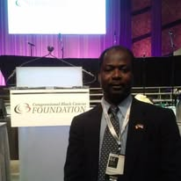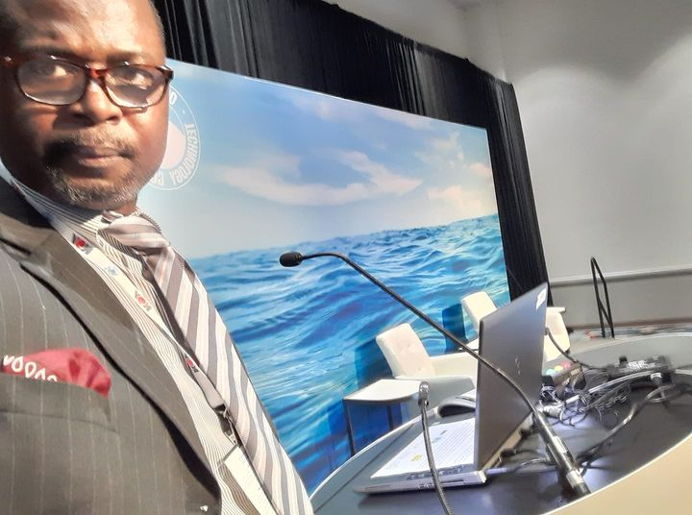
Civic journalism

6. SPECIAL REPORT
HEALTH EQUITY IN THE 21ST CENTURY
Confronting the Barriers, Advancing Justice, and Building Systems That Protect Every Life

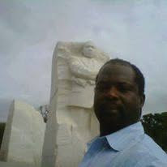

HEALTH EQUITY IN THE 21ST CENTURY
Confronting the Barriers, Advancing Justice, and Building Systems That Protect Every Life
Health equity is not a slogan. It is a moral imperative — and one of the defining challenges of the 21st century. Across the world, communities continue to experience preventable suffering not because cures do not exist, but because access does not. The gap between those who receive timely, quality care and those who do not remains one of the most persistent injustices of our time.
For more than three decades, Dr. Akwo Thompson Ntuba has worked at the frontlines of this struggle. His career — spanning medicine, governance, communication, and ministry — offers a rare, multidimensional perspective on what it will take to build a world where health is not a privilege, but a right.
This special report examines the forces shaping health equity today, the systems that perpetuate disparities, and the leadership required to create lasting change.
The Unequal Landscape of Global Health
Despite scientific breakthroughs and unprecedented technological advancement, health outcomes remain deeply unequal. Geography, income, race, gender, education, and political stability continue to determine who lives and who dies.
Across continents, disparities manifest in:
- Maternal mortality
- Chronic disease burden
- Access to essential medicines
- Mental-health services
- Emergency preparedness
- Environmental exposures
- Health-literacy gaps
These inequities are not accidental. They are the result of historical injustices, structural failures, and governance gaps that have accumulated over generations.
Governance: The Hidden Driver of Health Outcomes
One of the most overlooked determinants of health is governance. Strong governance creates systems that protect people; weak governance leaves communities vulnerable.
Dr. Ntuba’s work in health-system strengthening has shown that equity depends on:
- Transparent decision-making
- Ethical leadership
- Community participation
- Fair distribution of resources
- Accountability mechanisms
- Investment in primary care
- Crisis-response readiness
Without these foundations, even the best medical innovations fail to reach those who need them most.
The Role of Communication in Advancing Equity
Health equity cannot exist without health literacy. Communities must understand the risks they face, the resources available to them, and the policies that shape their wellbeing.
Dr. Ntuba’s global health communication work demonstrates that:
- Clear messaging saves lives
- Misinformation widens disparities
- Cultural competence builds trust
- Community-centered communication empowers action
- Media partnerships strengthen public-health response
In the 21st century, communication is not an accessory to health equity — it is a pillar of it.
The Social Determinants That Shape Health
Health is shaped far beyond the clinic. The conditions in which people live, work, learn, and worship determine their ability to thrive.
Key determinants include:
- Income and employment
- Education and literacy
- Housing and sanitation
- Nutrition and food access
- Transportation and mobility
- Environmental safety
- Social support networks
Dr. Ntuba’s work across continents has shown that addressing these determinants requires cross-sector collaboration — between governments, faith communities, civil society, and health institutions.
Climate Change: The New Frontier of Inequity
Climate change is reshaping global health in ways that disproportionately harm vulnerable populations. Rising temperatures, extreme weather, food insecurity, and vector-borne diseases are creating new layers of inequity.
Communities with the least resources face the greatest risks.
Dr. Ntuba’s training in climate-health and environmental determinants positions him as a leading voice in this emerging field. He advocates for climate-resilient health systems that protect those most affected by environmental change.
Faith, Community, and the Human Spirit
Health equity is not only a technical challenge — it is a human one. It requires compassion, solidarity, and moral courage.
Through his ministry and community work, Dr. Ntuba has demonstrated that faith-based organizations play a critical role in:
- Reaching underserved populations
- Providing emotional and spiritual support
- Mobilizing volunteers
- Delivering community-based care
- Advocating for justice and dignity
Equity requires both systems and spirit.
A Blueprint for the Future
To achieve health equity in the 21st century, the world must commit to:
- Strengthening governance
- Investing in primary care
- Expanding health literacy
- Addressing social determinants
- Building climate-resilient systems
- Supporting community-based leadership
- Ensuring ethical, transparent communication
These are not abstract ideals. They are practical steps — many of which Dr. Ntuba has championed throughout his career.
A Call to Action
Health equity is the unfinished work of global development. It demands leaders who are willing to confront injustice, challenge broken systems, and stand with the communities most affected.
Dr. Akwo Thompson Ntuba’s life and work remind us that equity is not achieved through policy alone — it is achieved through service, courage, and unwavering commitment to the dignity of every human being.
The 21st century will be defined by how boldly we pursue this vision.

7. VOICES FROM THE FIELD
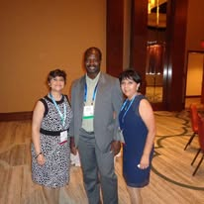

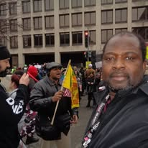
Testimonies of Leadership, Healing, and Human Connection Across Continents
Every great leader leaves a trail of transformed lives — people who carry the memory of a moment, a message, or a gesture that shifted their path. Over three decades of service, Dr. Akwo Thompson Ntuba has walked into communities facing crisis, uncertainty, and change. What remains long after he leaves are the voices of those he touched.
This section gathers those voices — from health workers, civic leaders, pastors, students, and everyday people — to paint a portrait of a man whose influence is felt not through titles, but through impact.
These are their stories.
“He listened before he spoke.”
— Public-Health Nurse, Kentucky
“We were overwhelmed. Testing lines were long, misinformation was everywhere, and people were scared. When Dr. Ntuba arrived, he didn’t start with instructions. He started by listening. He asked us what we were seeing, what we needed, and what we feared. That changed everything. He helped us rebuild trust with the community.”
“He brought clarity when we needed it most.”
— City Communications Officer, Houston
“During the pandemic, our messaging had to be precise. Dr. Ntuba helped us translate complex health guidance into language our communities could understand. He didn’t just communicate — he connected. People trusted him because he spoke with empathy, not authority.”
“His ministry healed wounds medicine could not reach.”
— Pastor, East Africa
“We invited him to speak at a revival after our community suffered a tragic loss. His message was simple: God sees your pain. People wept. Families reconciled. Young men who had lost hope found direction again. His ministry brought healing that no clinic could provide.”
“He treated us like partners, not subjects.”
— Community Health Worker, Cameroon
“Many consultants come with ready-made solutions. Dr. Ntuba came with questions. He respected our knowledge of our own community. Together, we built programs that actually worked. He made us feel seen.”
“He helped us understand the science without fear.”
— High-School Teacher, Louisiana
“Our students were confused about vaccines, viruses, and public-health rules. Dr. Ntuba visited our school and explained everything in a way young people could grasp. He didn’t talk down to them. He empowered them. Some of those students are now studying public health.”
“He stood with us when leadership failed.”
— Emergency Response Volunteer, Gulf Coast
“When systems broke down, he didn’t disappear. He showed up with a notebook, a camera, and compassion. He documented our struggles so the world would know what we were facing. His reporting helped us get resources we desperately needed.”
“He reminded us that governance is about people.”
— Local Government Official, Midwest U.S.
“In our leadership training, he said something I will never forget: ‘If your decisions do not protect the most vulnerable, they are not leadership decisions.’ That line changed the way I govern.”
“He carried our stories to the world.”
— Mother and Community Advocate, West Africa
“When our clinic lacked supplies, he interviewed us, photographed our challenges, and published our story. Within months, NGOs reached out. Supplies came. Our children received care. He didn’t just report — he advocated.”
“He made us believe we mattered.”
— Youth Leader, United Kingdom
“I met him at a conference. I was nervous, unsure of my path. He told me, ‘Leadership begins the moment you decide to serve.’ That sentence has guided my life ever since.”
A Tapestry of Impact
These voices — diverse in geography, background, and experience — share a common thread: Dr. Akwo Thompson Ntuba showed up. He showed up in moments of crisis, in seasons of rebuilding, in spaces where leadership was needed but not always present.
He showed up with humility. He showed up with clarity. He showed up with compassion. He showed up with purpose.
And in showing up, he left behind not just programs or policies, but people who felt seen, heard, and valued.
This is the legacy of a life lived in service. This is the story the field tells.

9. EXCLUSIVE INTERVIEW
“MY LIFE’S WORK IS SERVICE”
A Conversation with Dr. Akwo Thompson Ntuba
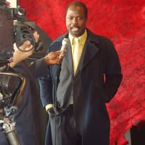
In this rare and intimate conversation, Dr. Akwo Thompson Ntuba reflects on three decades of global health leadership, ministry, governance, and civic journalism. His answers reveal a man shaped by purpose, disciplined by experience, and anchored by faith.
This interview captures the heart of his legacy — and the vision guiding his next chapter.
Q1. Dr. Ntuba, when you look back over your journey, what first awakened your calling to serve?
A: Service was not something I discovered; it was something I grew into. From childhood, I saw how communities survive through shared responsibility. I watched elders protect the vulnerable, and I learned early that leadership is not about position — it is about presence. Medicine gave me a pathway, but the calling was always bigger than the profession.
Q2. You have worked across medicine, governance, communication, and ministry. How do these roles connect?
A: To me, they are one work expressed in different ways. Medicine heals the body. Communication heals confusion. Governance heals systems. Ministry heals the soul. When you see people holistically, you cannot separate these dimensions. They are all part of restoring dignity.
Q3. What has been the most defining moment of your public-health career?
A: Moments of crisis reveal the true weight of leadership. During public-health emergencies, I saw how fear can spread faster than disease — and how clear communication can save lives. Standing with communities in those moments, helping them understand what was happening and how to protect themselves, shaped my understanding of what service really means.
Q4. You have documented governance and public-health leadership across the United States. What have you learned from that work?
A: Governance is not abstract. It is human. Decisions made in boardrooms affect families, neighborhoods, and entire generations. I learned that transparency builds trust, and trust is the foundation of every successful health system. When leaders forget the human impact of their decisions, systems break down.
Q5. Your ministry spans more than 25 years and multiple continents. How has ministry shaped your leadership?
A: Ministry taught me compassion. It taught me to see people beyond their circumstances. When you pray with someone in pain, when you sit with a family in grief, when you speak hope into a community facing despair — you learn that leadership is not about authority. It is about love expressed through action.
Q6. You have photographed and documented communities across Africa, America, and Europe. Why is documentation important to you?
A: Documentation is memory. It is accountability. It is heritage. When we document our work, we honor the people we serve and preserve their stories for future generations. My camera has been a companion in my journey — a witness to the resilience, beauty, and struggle of humanity.
Q7. What do you believe is the greatest challenge facing global health today?
A: Equity. We have the knowledge, the science, and the technology to improve health outcomes globally. What we lack is the moral courage to ensure that every person — regardless of geography or income — has access to care. Health equity is the unfinished work of our generation.
Q8. What advice would you give to young leaders entering the fields of health, governance, or ministry?
A: Lead with humility. Serve with integrity. Listen before you speak. And remember that leadership is not measured by how many people follow you, but by how many people are lifted because you showed up.
Q9. After three decades of service, what continues to motivate you?
A: People. Their resilience. Their courage. Their stories. Every time I see a community rise, a leader grow, or a life restored, I am reminded why I began this journey. Service is not something I do — it is who I am.
Q10. What do you hope your legacy will be?
A: I hope people will say that I served with compassion, that I stood with the vulnerable, that I strengthened systems, and that I helped others find their purpose. If my life inspires even one person to serve humanity with courage and love, then I have fulfilled my calling.
A Life Anchored in Purpose
This interview reveals what those who know him have always understood: Dr. Akwo Thompson Ntuba is a servant-leader whose life is guided by faith, shaped by compassion, and committed to the dignity of every human being.
His work continues — across continents, across disciplines, and across generations.

8. PHOTO ESSAY
A JOURNEY ACROSS CONTINENTS
Thirty Years, One Lens, A World of Stories
For more than three decades, Dr. Akwo Thompson Ntuba has carried a camera as faithfully as he has carried his stethoscope, his notebook, and his Bible. Across cities, villages, conferences, ministries, and crisis zones, he has documented the human condition with the eye of a healer, the heart of a minister, and the discipline of a historian.
This photo essay is not simply a collection of images. It is a global archive of service — a visual chronicle of a life lived in motion, in purpose, and in devotion to humanity.
Each photograph is a witness. Each frame is a testimony. Each city is a chapter in a story still unfolding.
Paris, France — The Diplomacy of Presence
In the shadow of the Eiffel Tower and the corridors of UNESCO, Dr. Ntuba captured the quiet dignity of global diplomacy. His images from Paris reflect a world negotiating peace, culture, and development — and the responsibility of leaders to protect the vulnerable.
London, United Kingdom — Governance in Transition
From Westminster to community halls, his London photographs document civic life in a city balancing tradition and transformation. They reveal the heartbeat of governance: people, policy, and the pursuit of justice.
Heidelberg & Padua — The Intellectual Cities
In Europe’s historic academic centers, Dr. Ntuba photographed scholars, physicians, and public-health thinkers shaping the future of medicine. These images honor the global pursuit of knowledge and the institutions that safeguard it.
Toulon & Toulouse, France — The Human Face of Development
His work in southern France captures communities navigating migration, health disparities, and social change. The images reflect resilience — families rebuilding, youth organizing, and leaders advocating for dignity.
New York City — At the United Nations
One of the most iconic images in this collection shows Dr. Ntuba standing before the United Nations memorial wall, honoring those who died in the cause of peace. His New York portfolio documents global diplomacy, humanitarian commitments, and the moral weight of international leadership.
Washington, D.C. — The Architecture of Power
From Capitol Hill to global health briefings, his Washington images reveal the machinery of policy-making — and the responsibility of governments to protect public health.
Houston, Dallas, Austin, San Antonio — The American South
In Texas, Dr. Ntuba documented civic leadership, public-health campaigns, ministry outreach, and community resilience. These images form one of the largest segments of his archive, capturing the intersection of governance, faith, and public service.
Los Angeles, San Francisco, Sacramento, San Jose — The Western Corridor
His West Coast photography chronicles innovation, diversity, and the challenges of urban health systems. From city halls to community clinics, these images show the complexity of American public health.
Seattle & Portland — Climate, Health, and Humanity
In the Pacific Northwest, Dr. Ntuba photographed climate-health intersections, environmental justice movements, and community-based resilience efforts — themes that now define 21st-century public health.
Denver & Aurora, Colorado — Healing in High Places
His Colorado images capture recovery-care programs, governance training, and community-health initiatives in cities navigating rapid growth and shifting demographics.
Tulsa, Memphis, Nashville, Bristol — The Heartland of Service
Across the American heartland, Dr. Ntuba documented ministry, civic journalism, and community empowerment. These images reveal the soul of America — its struggles, its faith, and its capacity for renewal.
Yaoundé, Cameroon — Returning to the Roots
In the capital of his homeland, Dr. Ntuba photographed governance, ministry, and community-health work. These images carry the emotional weight of origin — a return to the soil that shaped his calling.
Lagos & Ilorin, Nigeria — The Pulse of West Africa
His Nigerian portfolio captures the energy, complexity, and promise of one of Africa’s most influential nations. From health-system challenges to spiritual revival, these images reflect a continent rising.
A Global Archive for Future Generations
With more than 100,000 photographs, 8,000 video frames, and thousands of field notes, Dr. Ntuba has created one of the most comprehensive personal archives of global health, governance, ministry, and development in the modern era.
This archive is not merely documentation. It is heritage. It is evidence. It is legacy.
A museum-grade record of a life lived in service to humanity.
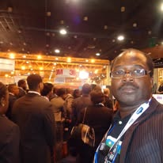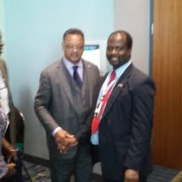

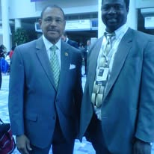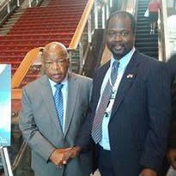

- CLOSING REFLECTIONS
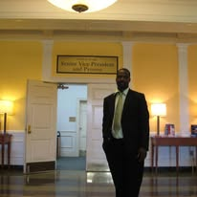

A Life of Service, A Legacy Still Being Written
As this special issue concludes, one truth rises above every story, every photograph, every testimony: Dr. Akwo Thompson Ntuba’s life is a living archive of service.
For more than three decades, he has stood at the intersection of medicine, governance, ministry, communication, and community. He has walked into places where systems were failing, where people were hurting, where leadership was absent — and he brought clarity, compassion, and courage.
He has served in the quiet moments no camera captured. He has stood in the public moments the world needed to witness. He has documented the human condition with the eye of a healer and the heart of a minister.
His legacy is not defined by titles. It is defined by impact.
By the communities strengthened. By the leaders mentored. By the systems reformed. By the lives uplifted. By the hope restored.
And yet, the most powerful truth is this: His story is not finished.
The next chapter — in global health, governance, ministry, and human development — is still unfolding. And the world is better because he continues to serve.

