“Prophetic Theology and Governance”
By H. E.E . M. DR NTUBA , THOMPSON AKWO
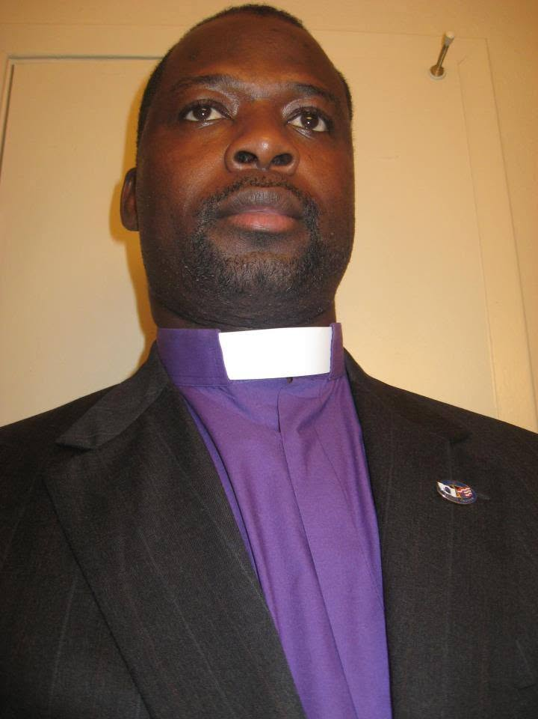
“Prophets of Liberation: Cone, Tutu, Gutiérrez, Kairos, and the African Voice of Dr. Ntuba”
Chapter Title:
“From the Crossroads to the Continent: Situating the Ntuba Theology within Global Liberation Traditions”
1. Introduction: The Global Cry for Liberation
- Liberation theology as a worldwide movement
- The African moment as the newest frontier
- Your biography as a bridge: medicine, governance, ministry, climate, Africa–America–Europe

2. James Cone: The Cross and the Lynching Tree
- God as the liberator of the racially oppressed
- Parallels with African postcolonial suffering
- Your critique of racialized global health inequities
3. Gustavo Gutiérrez: The Option for the Poor
- Poverty as structural sin
- The Church’s complicity with elites
- Your critique of Vatican–Africa political choreography
4. Desmond Tutu: Ubuntu and the Human Family
- Community as theology
- Apartheid as heresy
- Your insistence that African dignity is indivisible
5. The Kairos Document: Prophetic Theology in Action
- State Theology, Church Theology, Prophetic Theology
- Africa’s new kairos: corruption, authoritarianism, global silence
- Your prophetic denunciation of ecclesial hypocrisy
6. The Ntuba Contribution: A Theology of Governance, Health, and Global Responsibility
- Liberation through public health
- Liberation through climate justice
- Liberation through truthful governance
- Liberation through ecclesial accountability
7. Conclusion: The Future of African Liberation Theology
- A new generation of African prophetic leaders
- The Church as midwife of justice
- Your role as chronicler, physician, theologian, and global voice

TEACHING MODULE FOR YOUNG AFRICAN LEADERS: “Prophetic Theology and Governance”
Module Title:
“Leadership at the Crossroads: Prophetic Governance for a New Africa”
Audience:
Young African leaders (faith, civil society, medicine, governance, climate, media)
Duration:
3–5 sessions (flexible)
Session 1 — The Prophetic Tradition in Africa and Scripture
Objectives:
- Understand biblical prophetic leadership
- Identify African prophetic voices (Tutu, Biko, Wangari Maathai, Kairos theologians)
Content:
- Amos, Jeremiah, Jesus as models of truth-telling
- African prophets of justice
- The cost of prophetic leadership
Session 2 — Liberation Theology: Cone, Gutiérrez, Tutu, Kairos
Objectives:
- Learn global liberation frameworks
- Apply them to African governance challenges
Content:
- Cone: racialized power
- Gutiérrez: structural poverty
- Tutu: ubuntu and reconciliation
- Kairos: confronting unjust states and silent churches
Session 3 — The Ntuba Framework: Governance, Health, and Moral Responsibility
Objectives:
- Introduce your integrated model of leadership
- Show how governance failures become theological crises
Content:
- Health as liberation
- Climate as liberation
- Governance as moral stewardship
- The Church’s role in public truth
Session 4 — Practicing Prophetic Leadership
Objectives:
- Equip leaders with practical tools
- Build courage, clarity, and community
Content:
- Speaking truth to power
- Ethical decision-making
- Community-centered leadership
- Protecting one’s integrity in corrupt systems
Session 5 — Designing a Prophetic Action Plan
Objectives:
- Help each participant create a real-world project
Content:
- Identify a local injustice
- Apply prophetic frameworks
- Build partnerships
- Create measurable impact

SESSION 1 — THE PROPHETIC TRADITION IN AFRICA AND SCRIPTURE
Module: Prophetic Theology and Governance for a New Africa
Instructor: Dr. Akwo Thompson Ntuba
I. OBJECTIVES
By the end of this session, participants will:
1. Understand biblical prophetic leadership
- What makes a prophet
- How prophets confront power
- Why truth-telling is a form of governance
2. Identify African prophetic voices
- Desmond Tutu — moral courage and ubuntu
- Steve Biko — psychological liberation and Black consciousness
- Wangari Maathai — ecological justice and women’s dignity
- Kairos theologians — confronting apartheid with prophetic theology
3. Recognize the cost of prophetic leadership
- Social rejection
- Political persecution
- Institutional resistance
- Personal sacrifice
II. CONTENT
A. Biblical Prophets as Models of Truth-Telling
1. Amos — The Prophet of Justice
Amos stands as the clearest biblical voice against:
- corrupt elites
- economic exploitation
- religious hypocrisy
His message:
“Let justice roll down like waters.”
Amos teaches African leaders that silence in the face of injustice is sin, and that governance must be rooted in righteousness, not ceremony.
2. Jeremiah — The Prophet Who Refused to Lie
Jeremiah confronted:
- kings who wanted flattery
- priests who preached false peace
- a nation addicted to denial
His message:
“They dress the wound of my people as though it were not serious.”
Jeremiah teaches that prophetic leadership requires emotional endurance, because truth is rarely welcomed by those who benefit from lies.
3. Jesus — The Prophet Who Became the Standard
Jesus:
- confronted empire
- challenged religious corruption
- defended the marginalized
- exposed hypocrisy
- embodied courage
His message:
“The Spirit of the Lord is upon me… to bring good news to the poor.”
Jesus teaches that prophetic leadership is not optional for believers — it is the heart of discipleship.
B. African Prophets of Justice
1. Desmond Tutu — The Archbishop of Ubuntu
Tutu confronted apartheid with:
- moral clarity
- spiritual joy
- fearless truth
His theology of ubuntu (“I am because we are”) teaches that:
- injustice wounds the whole community
- reconciliation requires truth
- dignity is non-negotiable
Tutu shows that prophetic leadership can be both fierce and compassionate.
2. Steve Biko — The Prophet of Black Consciousness
Biko taught that:
- liberation begins in the mind
- oppressed people must reclaim their dignity
- fear is the greatest weapon of the oppressor
His message:
“The most potent weapon in the hands of the oppressor is the mind of the oppressed.”
Biko shows that prophetic leadership includes psychological liberation.
3. Wangari Maathai — The Prophet of Creation and Women’s Dignity
Maathai confronted:
- environmental destruction
- patriarchal systems
- political repression
Her Green Belt Movement was a prophetic act:
- planting trees
- restoring land
- empowering women
- resisting dictatorship
She shows that ecology, governance, and liberation are inseparable.
4. The Kairos Theologians — Prophets of a Nation in Crisis
The 1985 Kairos Document named:
- State Theology — religion used to justify oppression
- Church Theology — timid neutrality
- Prophetic Theology — truth, justice, and liberation
Their message:
Neutrality in the face of oppression is sin.
They show that prophetic leadership is a collective calling, not just an individual one.
C. The Cost of Prophetic Leadership
Every prophet — biblical or African — paid a price.
1. Social Cost
- Misunderstanding
- Isolation
- Loss of status
2. Political Cost
- Surveillance
- Arrest
- Exile
- Assassination (Biko, many African activists)
3. Institutional Cost
- Church resistance
- Accusations of being “too political”
- Attempts to silence or sideline
4. Personal Cost
- Emotional exhaustion
- Threats to family
- Loneliness
- Sacrifice of comfort
Prophetic leadership is costly — but silence is costlier.
III. SESSION CONCLUSION
This session establishes the foundation for prophetic governance:
- Prophets are truth-tellers, not fortune-tellers.
- Prophets confront power, not the powerless.
- Prophets defend the poor, not the palace.
- Prophets speak for the voiceless, not for the comfortable.
- Prophets shape nations, not just churches.
Africa’s future depends on leaders who carry this prophetic mantle — leaders who refuse silence, who reject corruption, who defend dignity, and who stand where God stands: with the oppressed.

SESSION 2 — LIBERATION THEOLOGY: CONE, GUTIÉRREZ, TUTU, KAIROS
Module: Prophetic Theology and Governance for a New Africa
Instructor: Dr. Akwo Thompson Ntuba
I. OBJECTIVES
By the end of this session, participants will:
1. Learn global liberation frameworks
- Black Theology (Cone)
- Latin American Liberation Theology (Gutiérrez)
- African Liberation Theology (Tutu)
- Prophetic Theology (Kairos Document)
2. Apply these frameworks to African governance challenges
- Corruption
- Ethnic violence
- Postcolonial authoritarianism
- Economic injustice
- Environmental degradation
- Church–state complicity
II. CONTENT
A. James Cone — Racialized Power and the Struggle for Dignity
1. Core Insight
Cone teaches that God identifies with the oppressed, especially Black people suffering under racialized power.
His famous line:
“God is Black.”
Meaning:
- God stands where the oppressed stand
- The Gospel is liberation, not neutrality
- Any theology that ignores injustice is false
2. Application to African Governance
Cone helps African leaders see:
- how colonial racial hierarchies still shape global economics
- how African elites sometimes reproduce the same oppressive patterns
- how liberation requires confronting both external and internal systems of domination
Cone’s framework empowers African leaders to:
- challenge racialized global health inequities
- expose neocolonial economic structures
- resist internalized oppression and elite mimicry
B. Gustavo Gutiérrez — Structural Poverty and the Option for the Poor
1. Core Insight
Gutiérrez teaches that poverty is not accidental — it is structural sin.
His foundational claim:
“To know God is to do justice.”
2. The Option for the Poor
This means:
- the poor are not objects of charity
- they are subjects of history
- the Church must take their side
3. Application to African Governance
Gutiérrez helps African leaders see:
- poverty as a political and moral failure
- corruption as a theological crisis
- development as liberation, not charity
His framework challenges:
- extractive economies
- elite capture of resources
- foreign aid models that disempower communities
Gutiérrez gives Africa a language to demand:
- equitable governance
- people-centered development
- dignity-based policy
C. Desmond Tutu — Ubuntu, Reconciliation, and the Human Family
1. Core Insight
Tutu’s theology of ubuntu teaches:
“I am because we are.”
Human dignity is shared, not individual.
2. Reconciliation with Truth
Tutu insisted:
- reconciliation requires truth
- forgiveness requires justice
- community requires accountability
3. Application to African Governance
Ubuntu helps African leaders:
- build inclusive societies
- heal ethnic wounds
- resist tribalism and division
- prioritize community over personal power
Tutu’s model is essential for:
- post-conflict healing
- transitional justice
- national unity
- ethical leadership
D. The Kairos Document — Confronting Unjust States and Silent Churches
1. Core Insight
The Kairos Document (1985) identified three theologies:
1. State Theology
Religion used to justify oppression.
2. Church Theology
Timid neutrality that avoids conflict.
3. Prophetic Theology
Truth-telling, justice, and liberation.
2. Application to African Governance
Kairos helps African leaders:
- identify when governments use religion to mask injustice
- recognize when churches become chaplains to power
- embrace prophetic leadership that confronts corruption
Kairos is a mirror for:
- authoritarian regimes
- manipulated elections
- state violence
- church silence
It teaches that:
Neutrality in the face of oppression is sin.
III. SYNTHESIS — APPLYING THE FOUR FRAMEWORKS TO AFRICA TODAY
1. Cone → Confront racialized global systems
- IMF/World Bank conditionalities
- global health inequities
- extractive industries
- migration injustice
2. Gutiérrez → Confront structural poverty
- corruption
- resource mismanagement
- inequitable development
- youth unemployment
3. Tutu → Build ubuntu-based governance
- national unity
- reconciliation
- community-centered leadership
- dignity for all ethnic groups
4. Kairos → Confront unjust states and silent churches
- authoritarianism
- political repression
- church complicity
- moral cowardice
IV. SESSION CONCLUSION
This session teaches young African leaders that liberation theology is not an academic subject — it is a governance framework, a moral compass, and a leadership ethic.
Cone teaches courage. Gutiérrez teaches justice. Tutu teaches humanity. Kairos teaches clarity.
Together, they form a prophetic toolkit for building a new Africa — one where truth is spoken, dignity is defended, and leadership is rooted in liberation.

SESSION 3 — THE NTUBA FRAMEWORK: GOVERNANCE, HEALTH, AND MORAL RESPONSIBILITY
Module: Prophetic Theology and Governance for a New Africa
Instructor: Dr. Akwo Thompson Ntuba
I. OBJECTIVES
By the end of this session, participants will:
1. Understand your integrated model of leadership
A framework where:
- governance is moral stewardship
- health is liberation
- climate is justice
- truth is a public good
2. See how governance failures become theological crises
- corruption as sin
- mismanagement as violence
- silence as complicity
- injustice as a wound to the body of Christ
3. Learn how the Church must function as a guardian of public truth
- not a chaplain to power
- not a neutral observer
- but a prophetic witness
II. CONTENT
A. Health as Liberation
1. Health is not a service — it is a human right
In your framework, health is:
- dignity
- justice
- liberation
- the foundation of human flourishing
2. Governance failures become health crises
When leaders:
- steal public funds
- underfund hospitals
- politicize medicine
- ignore epidemics
- suppress data
…it is not only mismanagement — it is theological violence.
Because:
When a government allows its people to die unnecessarily, it violates the image of God in them.
3. Health workers as prophetic actors
Doctors, nurses, and public health leaders become:
- defenders of life
- truth-tellers
- protectors of the vulnerable
Your own vocation embodies this truth: healing is a form of liberation.
B. Climate as Liberation
1. Climate injustice is a continuation of colonial injustice
Africa contributes the least to global emissions but suffers the most from:
- drought
- floods
- displacement
- food insecurity
- energy poverty
This is not an environmental issue alone — it is a moral and theological crisis.
2. Creation care is liberation work
Your framework insists:
- climate justice is human justice
- environmental destruction is violence against the poor
- energy transition is a moral mandate
3. African leadership must be prophetic in climate governance
This means:
- resisting extractive industries
- demanding global accountability
- protecting indigenous lands
- building clean energy futures
Climate leadership is prophetic stewardship.
C. Governance as Moral Stewardship
1. Governance is not technical — it is spiritual
In your framework:
- budgets are moral documents
- policies are ethical statements
- leadership is a sacred trust
2. Corruption is a theological crisis
Corruption:
- steals from the poor
- destroys public trust
- kills through neglect
- mocks God’s justice
Therefore:
Corruption is not merely illegal — it is sinful.
3. Leadership as service, not domination
Your model calls for:
- transparency
- accountability
- humility
- truth
- courage
Governance becomes a ministry of justice.
D. The Church’s Role in Public Truth
1. The Church must be a moral compass
The Church cannot:
- bless dictators
- hide behind protocol
- remain neutral
- prioritize ceremony over suffering
2. Silence is complicity
When the Church:
- avoids naming injustice
- refuses to confront corrupt leaders
- prioritizes diplomatic language
- protects its own image
…it becomes part of the problem.
3. The Church as prophetic witness
Your framework calls the Church to:
- defend the poor
- speak truth to power
- expose lies
- protect human dignity
- stand with victims
This is the African continuation of:
- Cone’s truth against racialized power
- Gutiérrez’s option for the poor
- Tutu’s ubuntu and reconciliation
- Kairos’s prophetic theology
But with a new frontier:
The Church must confront not only unjust states, but its own complicity in African suffering.
III. SYNTHESIS — THE NTUBA FRAMEWORK AS AFRICA’S NEW LIBERATION VOICE
Your framework integrates four liberation arenas:
1. Health as liberation
Healing bodies is healing nations.
2. Climate as liberation
Protecting creation is protecting the poor.
3. Governance as moral stewardship
Leadership is a sacred responsibility.
4. The Church as guardian of public truth
Faith without justice is hypocrisy.
Together, they form a holistic African liberation theology for the 21st century — one that speaks to pandemics, climate change, corruption, migration, and global inequality.
IV. SESSION CONCLUSION
This session teaches young African leaders that:
- Leadership is moral.
- Governance is spiritual.
- Health is sacred.
- Climate is justice.
- Truth is prophetic.
- Silence is betrayal.
- The Church must stand with the oppressed, not the powerful.
The Ntuba Framework is a call to African leaders to govern with courage, compassion, and prophetic clarity — because liberation is not only political; it is medical, ecological, spiritual, and communal.

Session 4 — Practicing Prophetic Leadership
Objectives:
- Equip leaders with practical tools
- Build courage, clarity, and community
Content:
- Speaking truth to power
- Ethical decision-making
- Community-centered leadership
- Protecting one’s integrity in corrupt systems

SESSION 5 — DESIGNING A PROPHETIC ACTION PLAN
Module: Prophetic Theology and Governance for a New Africa
Instructor: Dr. Akwo Thompson Ntuba
I. OBJECTIVES
By the end of this session, participants will:
1. Identify a local injustice that demands prophetic intervention
Not abstract injustice — but something visible, specific, and urgent in their community.
2. Apply global prophetic frameworks
Using insights from:
- Cone (racialized power)
- Gutiérrez (structural poverty)
- Tutu (ubuntu and reconciliation)
- Kairos (confronting unjust states and silent churches)
- Ntuba (health, climate, governance, truth)
3. Build partnerships for impact
Because prophetic leadership is communal, not solitary.
4. Create a measurable, time-bound action plan
A project that can be implemented, evaluated, and scaled.
II. CONTENT
A. Step 1 — Identify a Local Injustice
Participants begin by naming a concrete injustice in their environment. Examples include:
1. Health injustices
- lack of clinics
- maternal mortality
- corruption in hospital supply chains
- misinformation during epidemics
2. Governance injustices
- bribery
- police abuse
- rigged local elections
- land grabbing
- youth unemployment
3. Climate and environmental injustices
- polluted water
- deforestation
- illegal mining
- flooding due to poor planning
4. Social injustices
- gender-based violence
- ethnic discrimination
- exploitation of migrants
- school inequities
Participants must answer:
Who is suffering? Why? Who benefits? Who is silent?
This is the prophetic starting point.
B. Step 2 — Apply Prophetic Frameworks
Participants analyze their chosen injustice through five liberation lenses:
1. Cone — Where is racialized or identity-based power operating?
- Who is marginalized?
- Who controls resources?
- How is dignity denied?
2. Gutiérrez — What structural forces create or sustain this injustice?
- Policies
- Budgets
- Institutions
- Historical patterns
3. Tutu — How does this injustice violate ubuntu?
- Who is excluded from the community?
- What relationships are broken?
- What reconciliation is needed?
4. Kairos — What forms of State Theology or Church Theology are present?
- Is the government justifying injustice?
- Is the Church silent or complicit?
- What would Prophetic Theology demand?
5. Ntuba — How does this injustice affect health, climate, governance, and truth?
- Does it harm bodies?
- Does it damage creation?
- Does it corrupt leadership?
- Does it distort public truth?
This step transforms moral outrage into theological clarity.
C. Step 3 — Build Partnerships
Prophetic leadership is never solitary. Participants identify:
1. Community partners
- youth groups
- women’s associations
- local elders
- health workers
- teachers
2. Institutional partners
- churches and mosques
- NGOs
- clinics
- environmental groups
- legal aid centers
3. Strategic allies
- journalists
- lawyers
- academics
- diaspora networks
- reform-minded officials
Participants answer:
Who must be at the table for liberation to begin?
D. Step 4 — Create a Measurable Impact Plan
Each participant designs a Prophetic Action Plan with four components:
1. Problem Statement
A clear description of the injustice:
- who is harmed
- how
- why
- what is at stake
2. Prophetic Goal
A liberation-centered objective:
- reduce maternal deaths
- stop illegal logging
- expose corruption
- protect schoolgirls
- improve water access
3. Strategy and Activities
Concrete steps, such as:
- community forums
- policy advocacy
- media campaigns
- legal petitions
- environmental restoration
- health outreach
4. Measurable Indicators
Examples:
- number of people reached
- policy changes achieved
- clinics supplied
- trees planted
- cases documented
- funds recovered
Participants must answer:
How will we know liberation has begun?
III. SESSION CONCLUSION
This session transforms prophetic theology into prophetic action.
Participants leave with:
- a defined injustice
- a liberation analysis
- a coalition of partners
- a measurable plan
This is where leadership becomes real — where young Africans step into their calling as prophets of governance, healers of communities, protectors of creation, and guardians of public truth.

