HEALTHNDEVELOPMENT
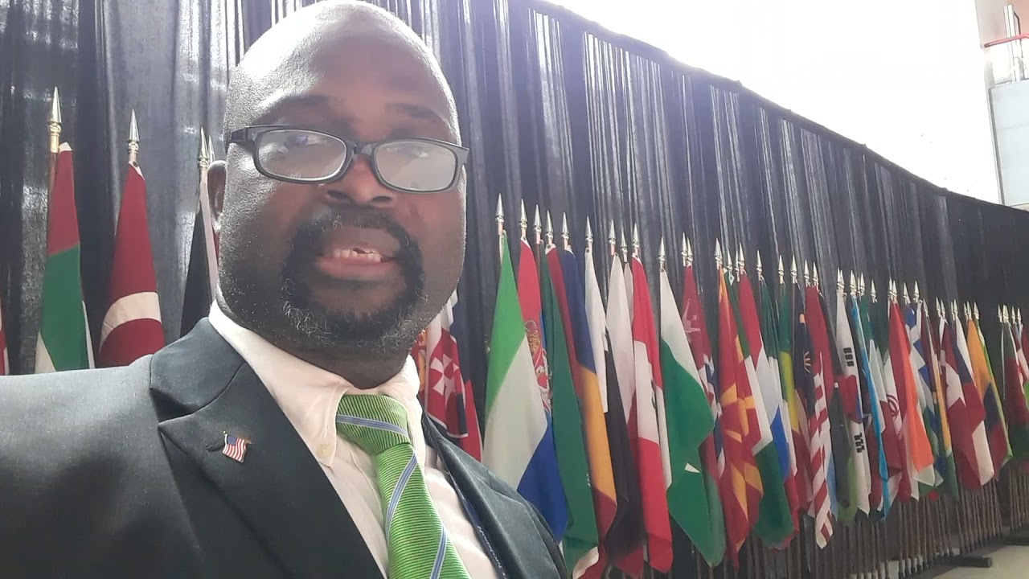
Home
- EDITORIAL
- EVENTS
- HEALTH
- NEWS
- WORLD CUP 2026
- EBOLA
- WHA2026
- INTERVIEWS
- DONALD TRUMP
- HANTA VIRUS
- Mental health
- IRAN -USA-ISREAL WAR
- Mid terms 2026
- FEATURE
- HOLIDAYS
- CANCER
- SPORTS
- HIV/AIDS
- CAMEROON PRESIDENTIAL 2025
- ROBERT ROBERSON CASE
- G7
- EDUCATION
- RELIGION
- WHO
- DEVELOPMENT
- ENERGY AND ENVIRONMENT
- SYLVESTER TURNER
- POLITICS
- SHIELER JACKSON LEE
- LINA HILDAGO
- COVID 19
- About Us
- ARCHIVED
- Blog
- Contact
- Archives
- BOOK " HEALING NATIONS "
- Archival Historical Series
- LEADERSHIP IN A FRAGMENTED WORLD
- BOOK : FROM CLIMATE TO COMMUNITY ".
- AT FRONT LINES OF PREPAREDNESS
- DOMINION RECOVERY
- BIOTECHNOLOGY
Chief Editor Dr Ntuba , Thompson Akwo

Dr. Ntuba Akwo Thompson stands out as a distinguished health and development journalist and communicator, whose extensive media credentials reflect his impactful career. His work has not only spanned continents but also bridged the gap between health professionals and the public, ensuring that vital information reaches diverse audiences.
As the Chief Editor of H&D Magazine, Dr. Thompson has played a pivotal role in disseminating critical health and development news. His work with cities , counties , states and federal , congress and federal government departments and participation in numerous high-profile events, as evidenced by his media credentials, underscores his commitment to these fields. From the HMSDC Networking Luncheon to the iGO Harris County Press Conference and the American College of Allergy, Asthma & Immunology conferences, Dr. Thompson has consistently been at the forefront of discussions that shape global health and development narratives.
Dr. Thompson's ability to communicate complex health topics effectively has made him a valuable asset in promoting awareness and understanding. His global presence, marked by his attendance at events in various locations, highlights his dedication to addressing health challenges on an international scale. Through his media work, he has not only informed but also inspired action, contributing to the betterment of communities worldwide.
In summary, Dr. Ntuba Akwo Thompson's career is a testament to the power of journalism and communication in driving health and development. His achievements, as showcased by his extensive collection of media credentials, reflect a legacy of excellence and a profound impact on global health through the lens of media.

Government Media and Press Work

Dr. Ntuba Akwo Thompson stands as a remarkable figure in the realm of health and development journalism, particularly through his contributions as a media partner to various city governments and mayors across the United States. His extensive work in civic journalism and political participation has been greatly bolstered by his collaboration with the City of Houston, under the leadership of Mayor Sylvester Turner, during pivotal moments such as the COVID-19 pandemic.
As a dedicated communicator and journalist, Dr. Thompson has harnessed his expertise to inform, educate, and empower communities on health and development matters. His role as Chief Editor of Health & Development Magazine has positioned the publication as a trusted resource, offering valuable insights and fostering awareness on global and local health challenges. His continuous coverage of the City of Houston and the State Capitol in Austin reflects his commitment to bridging the gap between civic institutions and the public, ensuring that vital information reaches those who need it most.
The image provided—an identification badge from Harris Health System, displaying Dr. Thompson's affiliation with H&D Magazine and his role in news media—offers tangible evidence of his contributions. It symbolizes his active involvement in the dissemination of health and development knowledge, as well as his credibility and prominence in the field.
Dr. Thompson's engagement during the COVID-19 pandemic highlights his adaptability and resolve in addressing emergent health crises through journalism. By partnering with the City of Houston, he played a crucial role in communicating public health guidelines and fostering a sense of unity during a time of uncertainty. This effort not only strengthened his civic and community journalism but also demonstrated the essential role of media in shaping public health responses.
Beyond the pandemic, his journalistic endeavors continue to make a lasting impact. Through Health & Development Magazine, Dr. Thompson provides a platform for dialogue, advocacy, and innovation in the health and development sectors. His unwavering dedication to covering critical topics and his ability to connect with diverse audiences reinforce the publication's reputation as a go-to source for reliable health and development resources.
In summary, Dr. Ntuba Akwo Thompson's achievements as a health and development communicator / journalist exemplify the transformative power of communication in addressing global challenges. His collaboration with city governments, particularly in Houston, underscores his role as a pivotal figure in civic journalism and political participation. Through his media work, he has established a legacy of excellence, bridging the worlds of health, development, and communication for the betterment of communities worldwide.

Dr. Ntuba Akwo Thompson stands as a remarkable figure in the field of health and development journalism, blending his medical expertise with a passion for impactful storytelling. As the Chief Health and Medical Editor of Healthndevelopment Magazine, Dr. Thompson has carved a niche for himself in the realm of health communication, leveraging nearly a decade of media experience both in the United States and internationally.
A trained physician with certifications in global health from Johns Hopkins University and USAID, as well as in health communication, Dr. Thompson's career reflects a unique intersection of medicine and journalism. His work spans major cities across the United States, including Washington, D.C., New York, San Antonio, Las Vegas, and Houston. Currently, he focuses on health and medical policy reporting in Houston and the Texas Capitol, showcasing his commitment to addressing critical health issues at both local and state levels.
Through Healthndevelopment Magazine, based in San Antonio, Texas, Dr. Thompson has created a platform that not only informs but also advocates for better health policies and practices. His journalism is deeply rooted in the principles of education and empowerment, aiming to bridge the gap between complex medical topics and public understanding. By doing so, he contributes to a more informed society capable of making better health decisions.
Dr. Thompson's affiliation with the Center for Health Journalism further underscores his dedication to excellence in health reporting. The Center, known for its mission to empower journalists to tell impactful health stories, aligns perfectly with Dr. Thompson's vision of using journalism as a tool for societal betterment. His work exemplifies the Center's values of rigorous reporting, community engagement, and addressing health disparities.
In a world where accurate and accessible health information is more crucial than ever, Dr. Ntuba Akwo Thompson's contributions to health and development journalism serve as an inspiring example of how expertise and passion can drive meaningful change. His efforts not only highlight the importance of health communication but also set a standard for future journalists in the field.
https://admycity.com/usa/san-antonio/details/healthndevelopment-magazine-media-7043-autumn-park-san-antonio-562301

Manta
https://www.manta.com › mhkflhv › healthndevelopment...
HealthNDevelopment Magazine & Media San Antonio TX, 78249 – …
Healthndevelopment magazine and media outlet business in San Antonio USA.

