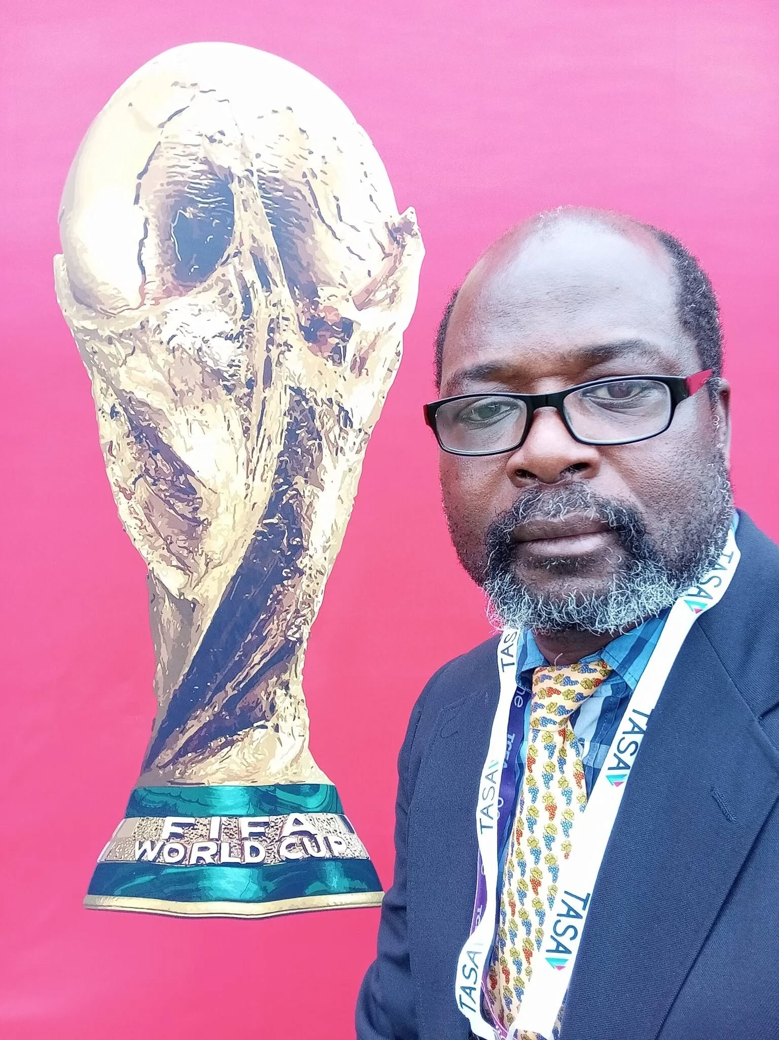
AN ESSAY TO TEXAS JOURNALISTS AND COLLEAGUES ON OBJECTIVE REPORTING DURING THE 2026 WORLD CUP

*DR. AKWO THOMPSON NTUBA WRITES:
AN ESSAY TO TEXAS JOURNALISTS AND COLLEAGUES ON OBJECTIVE REPORTING DURING THE 2026 WORLD CUP**
As the world turns its attention to North America for the 2026 FIFA World Cup, I write to my colleagues, fellow journalists, and media professionals across Texas—particularly those in Houston and Dallas, where I will be physically present and actively engaged. Many of you know my work, my discipline, and my standards. You also know one thing clearly: I do not play around when it comes to professional integrity, public health, or responsible communication.
As Chief of HealthNDevelopment Magazine and Media, my mandate has always been grounded in truth, evidence, and service to the public. The World Cup is not merely a sporting event; it is a global convergence of cultures, health systems, security frameworks, and political sensitivities. Our responsibility as journalists is not entertainment—it is objective reporting, grounded in facts, free from sensationalism, and anchored in the ethics that define our profession.
I. TEXAS AS A GLOBAL STAGE: WHY OUR WORK MATTERS
Houston and Dallas will not just host matches; they will host nations, governments, public-health teams, security agencies, and millions of supporters. The eyes of the world will be on Texas. Every headline, every image, every broadcast, and every analysis we produce will shape global perception.
This is why I insist on discipline, accuracy, and professional distance.
Journalism is not gossip. Journalism is not rumor. Journalism is not political manipulation.
Journalism is public trust.
II. OBJECTIVE REPORTING IN A HIGH-TENSION ENVIRONMENT
The World Cup brings excitement, but it also brings:
Heightened security enforcement
Strict public-health surveillance
Immigration and customs scrutiny
Cultural misunderstandings
Rapidly spreading misinformation
Our job is to cut through the noise.
We must report what is true—not what is trending.
We must verify before we amplify.
We must contextualize before we criticize.
In a world where misinformation travels faster than the ball on the pitch, the journalist becomes the last line of defense for public clarity.
III. MY PRESENCE IN HOUSTON AND DALLAS: A PROFESSIONAL COMMITMENT
I will be on the ground in both cities, not as a spectator, but as a global health expert, a development communicator, and a media leader. My work will focus on:
Monitoring public-health preparedness
Documenting global-health interactions around the tournament
Engaging with African delegations and health teams
Providing evidence-based commentary
Ensuring that HealthNDevelopment Magazine maintains its reputation for accuracy and integrity
Those who have worked with me know that I bring structure, seriousness, and a no-nonsense approach to every assignment. This World Cup will be no different.
IV. A MESSAGE TO TEXAS JOURNALISTS AND COLLEAGUES
To my colleagues across Texas newsrooms—print, digital, radio, and television—this is our moment to demonstrate what responsible journalism looks like in a global event.
I urge you to:
Avoid sensationalism
Respect cultural diversity
Report with empathy and precision
Collaborate across newsrooms when necessary
Protect the dignity of visiting teams and supporters
Uphold the ethics that define our profession
The world will judge Texas not only by the matches played, but by the stories we tell.
V. THE STANDARD WE MUST UPHOLD
As Chief of HealthNDevelopment Magazine and Media, I reaffirm our editorial principles:
Truth over speed
Context over confusion
Health and safety over hype
Professionalism over popularity
We are not here to entertain—we are here to inform.
We are not here to provoke—we are here to clarify.
We are not here to play—we are here to serve.
And as I always say:
You all know that I don’t play around.
VI. CONCLUSION: HISTORY IS WATCHING
The 2026 World Cup will be remembered for decades. Let it also be remembered as a moment when Texas journalists rose to the occasion—delivering reporting that was fair, factual, and globally respected.
Our pens, cameras, and microphones are instruments of public trust.
Let us use them wisely.
—Dr. Akwo Thompson Ntuba
Chief, HealthNDevelopment Magazine and Media
Global Health & Development Communicator
Houston–Dallas, Texas
See less

